


International Conference
Modelling and Methods of Structural Analysis
13-15 November 2019

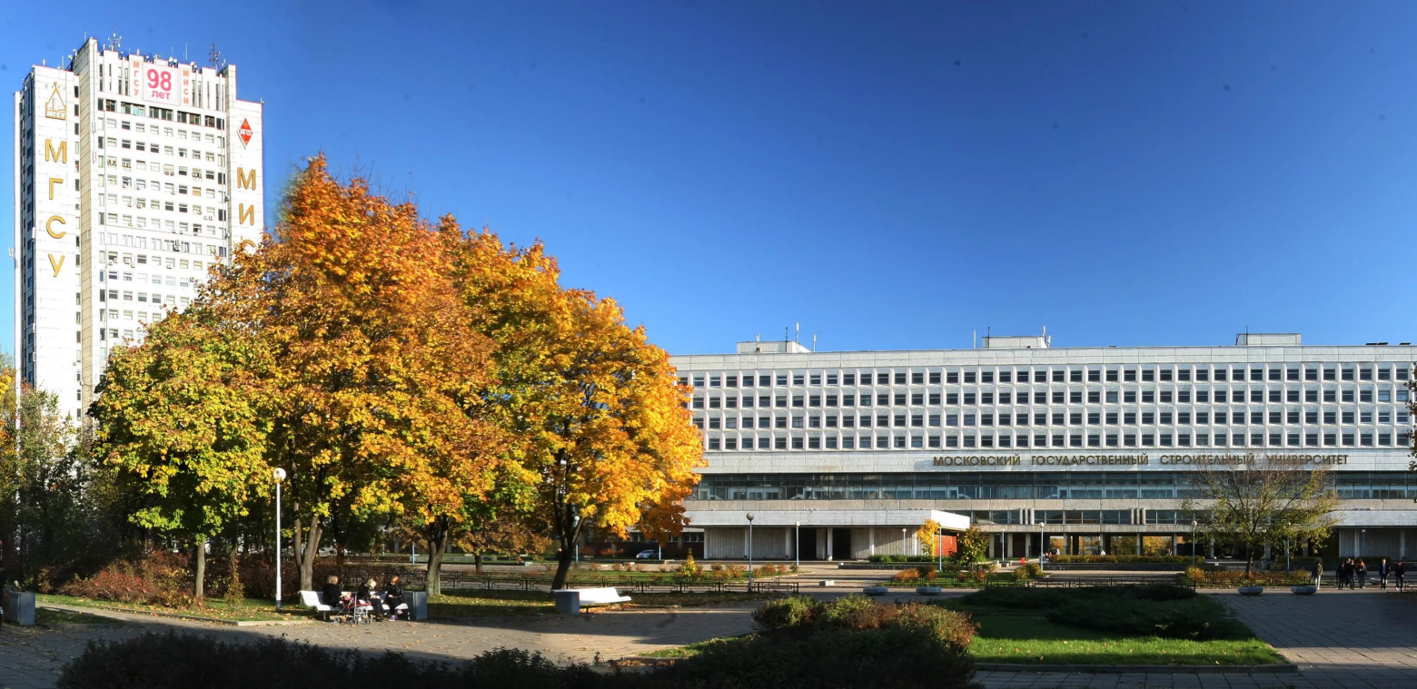

Мoscow State University of Civil Engineering
129337, Мoscow, Yaroslavskoye shosse, 26

МOSCOW 2019

Dear Participants and Guests of the Conference!
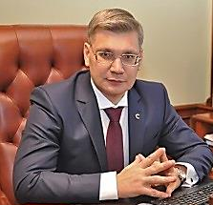
On behalf of the academic community of National Research Moscow State University of Civil Engineering (NRU MGSU) I am glad to welcome you at the International Conference “Modelling and Methods of Structural Analysis” hosted by our University for the first time. The Conference is meant to unite researchers, professional experts, professors and academic staff as well as wide range of participants representing professional communities of the Russian Federation and other countries concerned.
Highly eventful programme of the Conference, the list of well-established organizations-participants and devoted engagement of many colleagues throughout all the stages of Conference preparation instill confidence in practical importance of mutual initiative. The framework of the Conference comprises open and significant discussions regarding the problems of theory and practice of modelling, visualization, and structural analysis based on the advanced scientific and research methods; innovative ideas and approaches to solution of the problems of safety, reliability and efficiency of buildings and structures are to be proposed and discussed; the new possibilities of application and development of cutting-edge computational complexes for solution of scientific and engineering issues of high-tech construction development are to be thoroughly considered.
Initialized realization of national projects, such as “Science”, “Education”, “Dwelling and Urban Environment”, practically defines new planning horizons for the total system of applied science and education. It is evident that NRU MGSU and the association of our regional universities-partners should not only assume a highly active position in this aspect but also carry out the main principal mission and undertake overall responsibility for a qualitative step forward in order to enhance scientific staff potential required for construction industry progress.
I express strong confidence that out Conference would become one of the venues for demonstration of scientific achievements of international class by leading scientists and young scholars and would facilitate strengthening of academic cooperation, meanwhile the Conference proceedings would be expressed not only in the form of international scientific publishing but in the form of practical implementation in real projects.
I wholeheartedly wish you all success and efficient scientific collaboration!

Chairperson of the Organizing Conference Committee,
H.T. Rector of National Research
Moscow State University of Civil Engineering (NRU MGSU),
Corresponding member of the Russian Academy of
Architecture and Construction Sciences,
Professor, Doctor of Engineering Science
Andrey Anatolyevich Volkov

SUB-FORUMS AND SCIENTIFIC BRANCHES OF CONFERENCE
Mathematical and computer-aided modelling
- Methods and algorithms of mathematical and computer-generated simulation.
- Modelling of fatigue accumulation and failure of structures.
- Modelling of loads and actions imposed on structures, buildings and complexes. The problems of aero elasticity and hydro elasticity.
- Modelling of lifecycles of buildings, structures and complexes.
- The systems of computer-aided mathematics.
- Intelligent computations, analysis, and visualization of data and program software.

Buildings structures, structural analysis
- Development, research and further elaboration of numerical and analytical methods of structural analysis of buildings and structures.
- Structural evaluation of a structure as a whole and its elements.
- Enhancement of life of a structure and estimating of the remaining operating life of buildings structures.
- Structural theory of engineering buildings and structures.
- Unique buildings and structures, advanced principles of computational model generation and analysis.
- Methods of dynamic problems solution.
- Theory of oscillations of elastic and visco-elastic members of building structures.
- Structural analysis of buildings and structures for specific loads combination.
- Identification of computed dynamic parameters of buildings and structures.
- Verification and validation of models for engineering computations.
- Monitoring of buildings and structures.
- Seismic monitoring of buildings and structures, evaluation of seismic stability of residual seismic stability.

Mechanics of Materials
- Hypothesis and theories of mechanics of strained bodies.
- Strength and fracture mechanics of materials of building structures.
- Enhancement of durability and evaluation of remaining life time for building structures on the base of complex approach to the methods of assessment of current state of building structures.
- Non-linear material models of buildings and structures.
- Computational fracture mechanics for the problems of fail-safe structures.
- Computer-aided modellings and mathematical methods for description of mechanical behavior of materials of building structures.

IMPORTANT DATES
2019

Paper submission and registration
till 13.10.2019
Notification of acceptance
till 26.10.2019
Last fee payment
1.11.2019
Conference
13-15 November 2019

INFORMATION SUPPORT
The official website of the International Conference "Modelling and Methods of Structural Analysis» http:/www.mmsa2019.org

LANGUAGE OF THE CONFERENCE
English

CONFERENCE PROCEEDINGS PUBLISHING
Scientific papers/reports (in English) submitted by the Conference’ participants are to be published in a scientific journal indexed in Scopus/WOS databases. You can find the paper template, as well as general information regarding paper/report submission and publication fee on the Conference website.

CONTACTS
Assistant editor:
Sokolova Alla Germanovna, PhD. in Engineering, assistant professor of the Department of foreign languages and professional communications, NRU MGSU.
e-mail: mmsa@mgsu.ru, SokolovaAG@mgsu.ru
Editor’s office members:
Orlov Viktor Nikolayevich, Doctor of Physical and Mathematical Sciences, assistant professor of the Department of Applied Mathematics, NRU MGSU. e-mail: mmsa@mgsu.ru, OrlovVN@mgsu.ru
Tyupenko Natalya Aleksandrovna, PhD. in Pedagogy, assistant professor of the Department of Russian as a Foreign Language, NRU MGSU. e-mail: mmsa@mgsu.ru, TyupenkoNA@mgsu.ru
Starostina Ekaterina Andreevna, records manager, Institute of Fundamental Education, NRU MGSU. e-mail: mmsa@mgsu.ru, Starostinaea@mgsu.ru

Address: 129337, Moscow, NRU MGSU, Yaroslavskoye shosse, 26
Tel. +7 (499) 183-28-91 (eng/rus)
+7 (499) 183-19-29, +7 (499) 182-16-87 (rus)
e-mail: mmsa@mgsu.ru

